PRATIK KUNDU

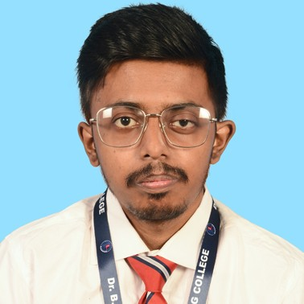I/24, NUTAN PALLY, BENACHITY, DURGAPUR, WEST BENGAL-713213

9609155856 | [kundupr](mailto:kundupratik07062001@gmail.com)[atik07062001@gmail.com](mailto:atik07062001@gmail.com) https://learn4you.online/



Objective

To pursue my career in an organization with a performance-oriented environment that values personal advancement. Being ambitious and hardworking, I look forward to challenging my potential and skills to deliver value-added results while further enhancing my learning and developing my career.



Personal Details

Date of Birth

Nationality Religion

: 07/06/2001

: INDIAN

: HINDUISM

Gender : MALE

: https:/[/www.linkedin.com/in/pratik-kundu-413474248?](http://www.linkedin.com/in/pratik-kundu-413474248)

LinkedIn utm_source=share&utm_campaign=share_via&utm_content=proﬁle&utm_medium=android_app

GitHub : https://github.com/PRATIK-KUNDU



Education

|  |  |
| --- | --- |
| MAULANA ABUL KALAM AZAD UNIVERSITY OF TECHNOLOGY  Master Of Computer Application(MCA) Pursuing | 2023-2025 |
| KAZI NAZRUL UNIVERSITY  B.Sc. Computer Science(Hons.) 88.8% | 2020-2023 |
| ASSEMBLY OF GOD CHURCH SCHOOL  Class XII (ISC) 81% | 2019-2020 |
| ASSEMBLY OF GOD CHURCH SCHOOL  Class X (ICSE) 83% | 2017-2018 |

Skills

Programming Language:- JAVA PYTHON

C

HTML CSS

SQL WORDPRESS

GOOD WRITTEN AND VERBAL COMMUNICATION



Projects



LIBRARY MANAGEMENT SYSTEM

Role:- Front-End-Developer

(Under Smitaparna Roy In Michael Madusudhan Memorial College)



Achievements & Awards

Topper in Class-X and also in Class-XII School Vice-Captain in Class-X

School House-Captain in Class-XI School Vice-Captain in Class-XII Excel in Sports and Academics



Certiﬁcation

Basics in Computer from TechView Team (15-08-2021)

Spoken English Course from George Telegraph Institute (22-02-2021)

Coding Development & Advanced Engineering Virtual Experience from Accenture (19-09-2021)



Internship

INTERNSHIP WITH CODSOFT

I have successfully completed a 4 week of virtual intership in JAVA PROGRAMMING with CodSoft (10/04/2024-10/05/2024)



Interests

Reading Writing

Hackathons



Languages

English Hindi Bengali

GitHub

https://github.com/PRATIK-KUNDU



PRATIK KUNDU